Invitation
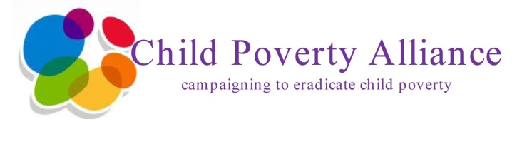
Chris Lyttle (MLA) and Steven Agnew (MLA)
(Chair & Deputy Chair of the All Party Group on Children & Young People)

Request the pleasure of your company
At the launch of the report
Beneath the Surface: Child Poverty in Northern Ireland

in the
Long Gallery, Parliament Buildings, Belfast
on behalf of the
Child Poverty Alliance
on
Monday 3rd November, 2014
at
10.00am – 12.00 noon

Note: places are limited and will be allocated on a first come first served basis
RSVP not later than 27th October to Ruairi Rowan, Ruairi@ci-ni.org.uk

NB: Present invite at the Massey Avenue entrance to Stormont Estate and on entry to Parliament Buildings
(this is a personal invitation and is not transferable)

Reply Slip

Launch of Beneath the Surface: Child Poverty in Northern Ireland
Long Gallery, Parliament Buildings, Belfast
Monday 3rd November, 2014
10.00am – 12.00 noon

Yes, I will attend the above event
No, I will not attend the above event
(tick appropriate box)

Name: ____________________________________________________________
Organisation: _______________________________________________________
Address: __________________________________________________________
Postcode: __________________________________________________________
Tele: ___________________ Email: ___________________________________
My vehicle registration number is: _______________________________________
Please detail if you require any special access arrangements: ____________________________________________________________________________________________________________________________________

