IoA Service Referral Form
Section 1: Client Contact Details
Title
First Name
Surname
Address | 1.  2.  Town/City  County  Postcode
Mobile
Home Phone
Any other contact info | E.g. other phone numbers, email address
Gender
DOB
Age
GP Name
GP Address | Surgery  1.  Town/City  County  Postcode
Next of kin or safety contact name and relationship to client
Next of kin or safety contact details | Tel. no.:  Address  Postcode

We will contact the client as soon as possible and no later than 7 days of receiving this referral form
Section 2: Referral Information
Reason for referral

Details of any relevant health condition and support needs
Other supports in place | Agency:  Name:  Address:  Tel: | Agency:  Name:  Address:  Tel:

This project offers a range of services; please tick below any which you / your client may be interested in
Counselling  Up to 10 solution focused counselling sessions to help understand feelings around alcohol and triggers and how to manage these | Mentoring  Up to 12 personal sessions with a mentor who will assist with identifying practical ways to reduce and manage alcohol intake and build daily routine | Personal Development Course  12 week structured programme covering topics such as health, well-being, confidence building, and future planning.

Please provide a few words on how you hope this project will help this person

Section 3: Demographics
Sexual Orientation
Religious Background
Relationship Status
Employment Status
Ethnicity
Country of Origin
Dependents 17 and under
Dependents 18 and over
Disabilities | 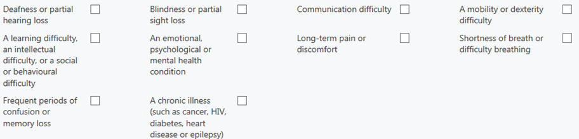

Section 4: Referral information
First Referral for this client? | Yes / No
Referrer name and relationship to client
Referrer Address | 1.  2.  Town/City  Postcode
Referrer Tel No.
Referrer Email
Please give details of care plan, if any:
Can you share details of the client’s most recent assessment or care plan? Yes / No
Would you like to be kept updated on this client? Yes / No

If sending this referral form via email, please send as a password protected document to ensure client confidentiality, using either the provided password or one of own choosing which can be emailed separately

