This template can be used to record the issues raised during discussions with children and young people in preparation for their individual completion of the online survey.
If you decide to record the examples or issues they raise, you can complete relevant sections of this template and email it to Sinead McSorley at Children’s Law Centre: sinead@childrenslawcentre.org and this information will be incorporated into the children and young people’s report.
Note: Please enter your notes and observations in the boxes provided. You can extend the size of the boxes if you need more space.

School or organisation: …………………
Number of children / young people in session: ….
Age range: ……..

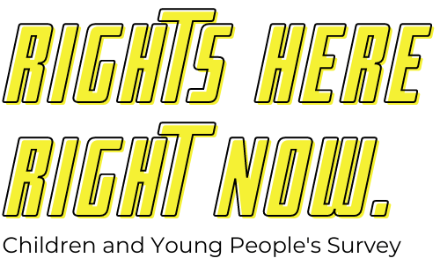

UNCRC Article 12: Voice of the Child (Participation)

Question for children and young people: Do you think your views and opinions are heard and taken into account?

In your family? | Yes (number):  Examples (please list) | No (number):  Examples (please list)
At school / college? | Yes (number):  Examples (please list) | No (number):  Examples (please list)
In your community? | Yes (number):  Examples (please list) | No (number):  Examples (please list)
In decisions made by politicians? | Yes (number):  Examples (please list) | No (number):  Examples (please list)
UNCRC Article 2: Non-Discrimination

Question for children and young people: Do you think children and young people are discriminated against or treated unfairly on the basis of their age?

Yes (number):  Examples of age related discrimination (please list): | No (number):  Examples (please list):
Question for children and young people: Do you think there are any specific groups of children and young people who experience prejudice [preconceived opinions, not based on fact or actual experience] or discrimination [being treated unfairly or differently]?

In school? | Yes (number):  Examples (please list) | No (number):  Examples (please list)
In the community? | Yes (number):  Examples (please list) | No (number):  Examples (please list)
In the media? | Yes (number):  Examples (please list) | No (number):  Examples (please list)

UNCRC Article 6: Survival and Development

Question for children and young people: What do you think is important for children and young people’s development?

What do children and young people need to be healthy? | Examples (please list):
What do children and young people need to be safe and protected? | Examples (please list):
What do children and young people need to develop to their fullest potential? | Examples (please list):
What do children and young people need in preparation for living independently? | Examples (please list):
What circumstances support children and young people's wellbeing and development? | Examples (please list):
What circumstances negatively affect children and young people’s wellbeing and development? | Examples (please list):
Question for children and young people: What help and support do children and young people need to develop to their fullest potential?

In their families or alternative care? | Examples (please list):
Education? | Examples (please list):
Health? | Examples (please list):
Youth and community provision? | Examples (please list):
UNCRC Article 42: Knowledge about Children's Rights and the UNCRC

Question for children and young people: What rights do you think children and young people should have?

List each right: | Is this right promoted and protected here?
 | Yes (number): | No (number):
 | Yes (number): | No (number):
 | Yes (number): | No (number):
 | Yes (number): | No (number):
 | Yes (number): | No (number):
 | Yes (number): | No (number):
 | Yes (number): | No (number):
 | Yes (number): | No (number):
 | Yes (number): | No (number):
 | Yes (number): | No (number):

Question for children and young people: If you could change one thing for children and young people here, what would that be?

Suggestions (please list):

Question for children and young people: To make things better for children and young people, what advice would you give to the government here [NI Executive]

Suggestions (please list):

