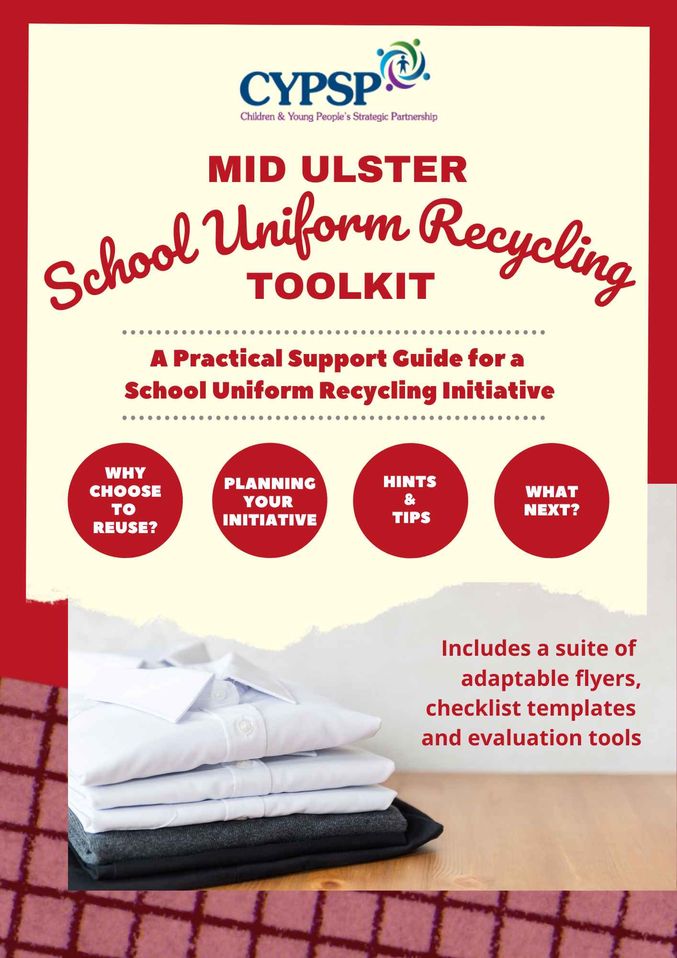

TOOLKIT ITEM | PAGE
Acknowledgements  &  How to use the Toolkit | PAGE 2
Background to the Toolkit | PAGE 3
Evidence: Why run a School Uniform Recycling Initiative? | PAGE 4
Who can run a School Uniform Recycling Initiative? | pages 5 & 6
Points for Discussion  (Including Checklist) | pages 7 - 12
Evaluations and What Next? | page 13
Templates to Use | page 14 - 18
Further Information and Resources | page 19
Timeline for Running an Event | page 20
Eco Schools | page 21
Volunteering | page 22

Thanks to members of both the Dungannon and Mid Ulster Locality Planning Groups (LPGs): local partnerships working towards improving outcomes for children, young people and families across Northern Ireland. Participating organisations are included at the end of the document.

Thanks to the PTA of Magherafelt High School for their support and feedback on the Toolkit and to those participating schools in the Mid Ulster area.

Thanks also to the authors/owners of the various resources and further reading we have included throughout the Toolkit.

This Toolkit has been produced as a practical resource for schools in running a School Uniform Recycling Initiative. This includes handy tips, suggested structures for discussion, templates to adapt and use, and links to further reading and resources.

You can print out the Options (Page 6) and Checklist (Pages 8-12) and use as discussion prompts, completing the boxes and keep as a record of discussion. You may wish to increase the copies to A3 size or copy the tables onto a flipchart page. The Discussion notes at the bottom of the Checklist sections lets you add any further notes of your discussion.

For the templates shown on Page 15 and Page 16 you are able to
amend details where relevant to advertise your initiative/event.
This includes adding your school logo, name and details of your
initiative. These can be done in the indicated areas in brackets.

On the Inventory (Template 5) which accompanies this
resource, you can add any details in the relevant headings
in the Microsoft Excel spreadsheet.

All words or phrases which are in grey and underlined can be clicked on to take you to the relevant resource, further reading or e-mail. We have also included a link for further resources which is on Page 19. This includes many articles and evaluations of other School Uniform Recycling Initiatives.

The Timeline on Page 20 can be printed/used as a reference guide for all involved.

For any clarification or assistance, please do not hesitate to contact us at localityplanning@ci-ni.org.uk

This Toolkit has been produced in partnership by member organisations and services of both the Dungannon and Mid Ulster Locality Planning Groups (LPG’s). Members of both LPG’s identified poverty as a critical factor which can adversely affect families which has been further exacerbated by the impact of Brexit and Covid-19 pandemic in recent years. It was agreed to produce a practical toolkit to support schools in the running of a School Uniform Recycling Initiative.

Locality Planning Groups are partnerships between statutory, voluntary and community organisations working with and for children, young people and families at a local level. Their work focuses on early intervention to improve outcomes for children and young people. They are one of the functions of the Children and Young People’s Strategic Partnership (CYPSP) operating across Northern Ireland.
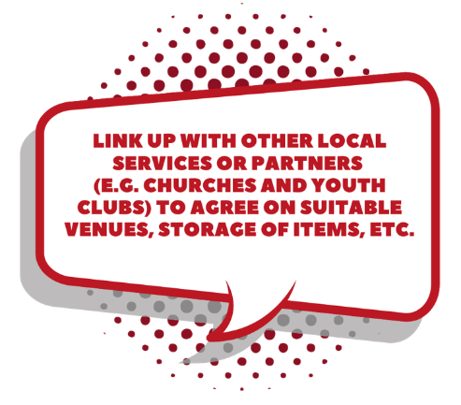

School Uniform Recycling Initiatives have taken
place across Northern Ireland involving schools,
voluntary and community sector bodies. The partners
of Mid Ulster and Dungannon LPGs agreed to
combine to produce a Toolkit aimed at Primary and
Post Primary schools in the Mid Ulster Council area,
to help them organise and run an initiative which
bests suit their circumstances and resources.

In late 2021, contact was made to all schools in the area via a Survey Monkey link, asking whether they already run a School Uniform Recycling Initiative and happy to share their experiences or did not but would like to find out more. 20 schools responded with the following breakdown of replies:
- 8 schools already ran a school uniform recycling initiative, 8 did not
- 5 schools running a school uniform recycling initiative were agreeable to sharing their learning with us
- 13 schools were interested in finding out more with the view to running an initiative in Spring/Summer 2022

This Toolkit aims to provide practical support to schools in the Mid Ulster Council area, in setting up and running a School Uniform Recycling Initiative which is sustainable and responsive to individual need.

Across the UK, including Northern Ireland, we throw away 1,000,000 tonnes of textile waste each year with 300,000 tonnes ending up in Landfill. We buy more clothes than any EU country and have 5 times more clothes than our grandparents.

In the UK each year, every student creates 7kg of school uniform waste. In 2020-21 there were 30,352 pupils (primary and post primary schools) creating a total of 212.464 tonnes of uniform waste in Mid Ulster, the majority of which going to landfill.

Research in Northern Ireland by the Parents Engagement Group states the average cost of a Primary School uniform is £173 and post primary £378. The average spend for primary school pupils is £315 and £337 for post primary. School uniform grants for families in Northern Ireland are greatly lower than that of their UK and Republic of Ireland neighbours, currently £35.73 for a Primary school pupil and £73-£78 per post primary pupil.

Compilers of this Toolkit recognise the sensitive political implications currently existing around school uniform affordability and the debates held at a higher policy level, however, wish to assert that the toolkit aims to be a practical local solution focusing primarily on the environmental benefits while helping to ease the financial burden brought about by purchasing of school uniforms for all children.

Anyone can run a School Uniform Recycling Initiative. Activities have been co-ordinated and run by Schools, Community Groups and Associations, Churches, Food Banks and Local Partnerships like the CYPSP, consisting of key local organisation aiming to provide family support.

For the purpose of this Toolkit, we are focusing on schools in the Mid Ulster District Council area.

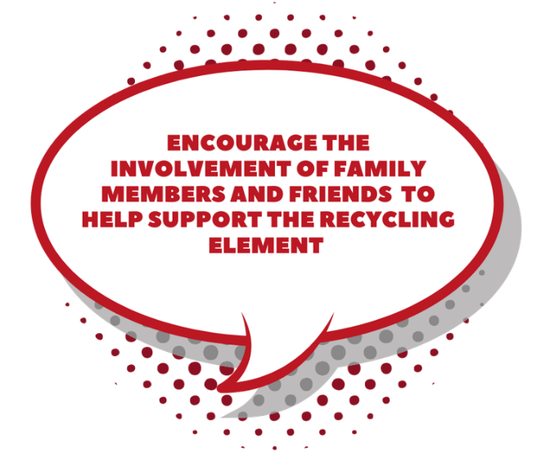
If you are considering running a School Uniform Recycling
Initiative for your school, chat with parents, teachers and
students from your school community to establish if
others would like to become involved. Bring your
idea to the school and PTA’s attention that this
is something the school community would be
interested in. If this is something the school
or PTA is not interested in, perhaps a local
community group may take on the task with
help and support.

We strongly recommend engaging with pupils of the school to become involved from the beginning, to create a collective approach with ownership spread across the school. The Student/School Council, Lower Sixth Students or Eco-Committee would be a natural starting point in this respect.

We have included further information
about Eco-Schools and volunteering
recognition on pages 21 and 22.

To summarise, we have pulled together some options, to help you think about the best approach for your school. (A template is provided on the next page, with these options included, to print out and use as a discussion tool to weigh up the pros and cons to help decide what is best for your school.)
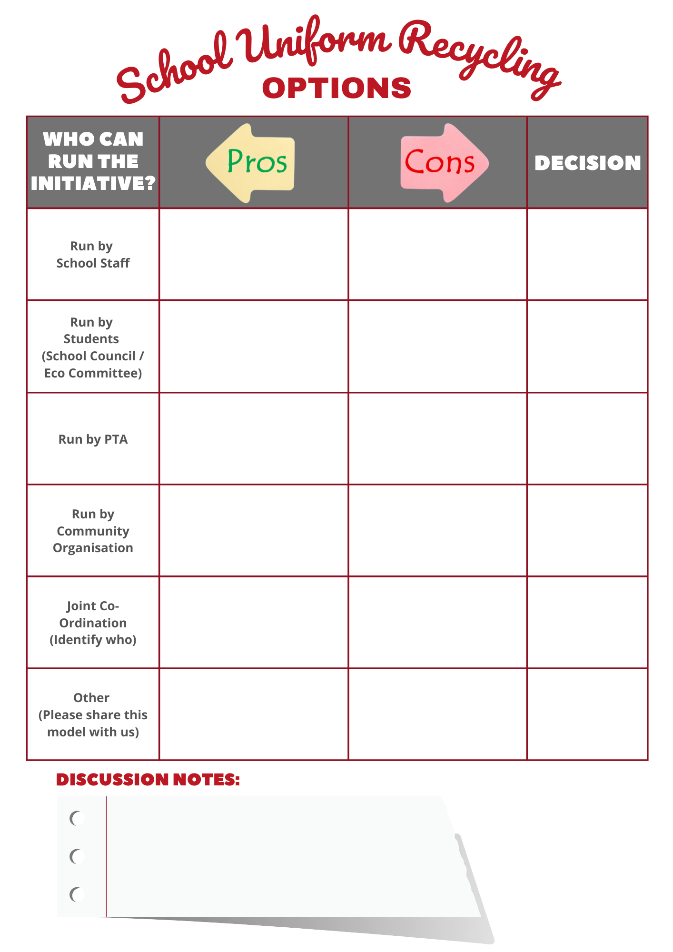

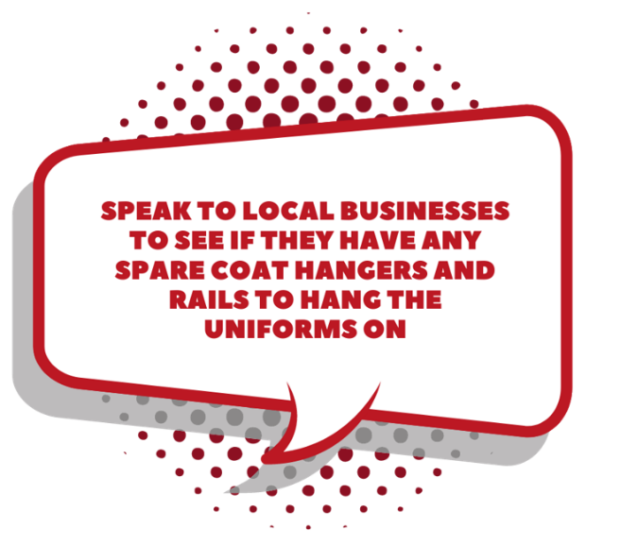
As stated, we are not aiming to provide a prescriptive model to be adhered to - flexibility is key.

This section provides a key Checklist for you
to have discussions with teaching staff,
parents, students and any other
partners with whom you will be
working. These will then help to
produce a clear action plan.

(See the following four pages for a printable version of the Checklist.)

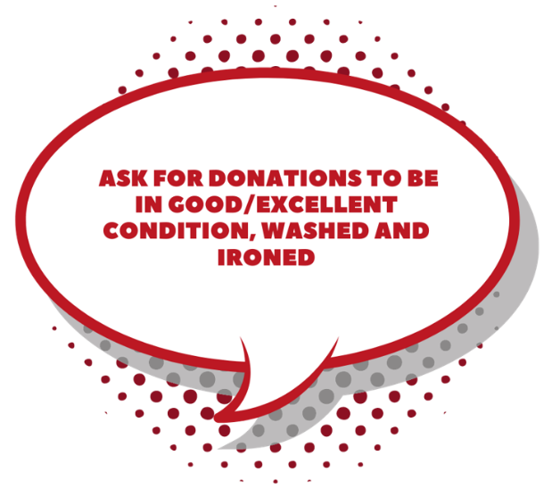

N.B. If this event is run by the school’s Eco Schools Council, the initiative can contribute towards achieving Green Flag Award status. To find out more, click HERE.

If this event is run by students, the initiative can contribute towards achieving volunteering hours.

Visit Pages 21 and 22 to read more about Eco Schools and Volunteering.
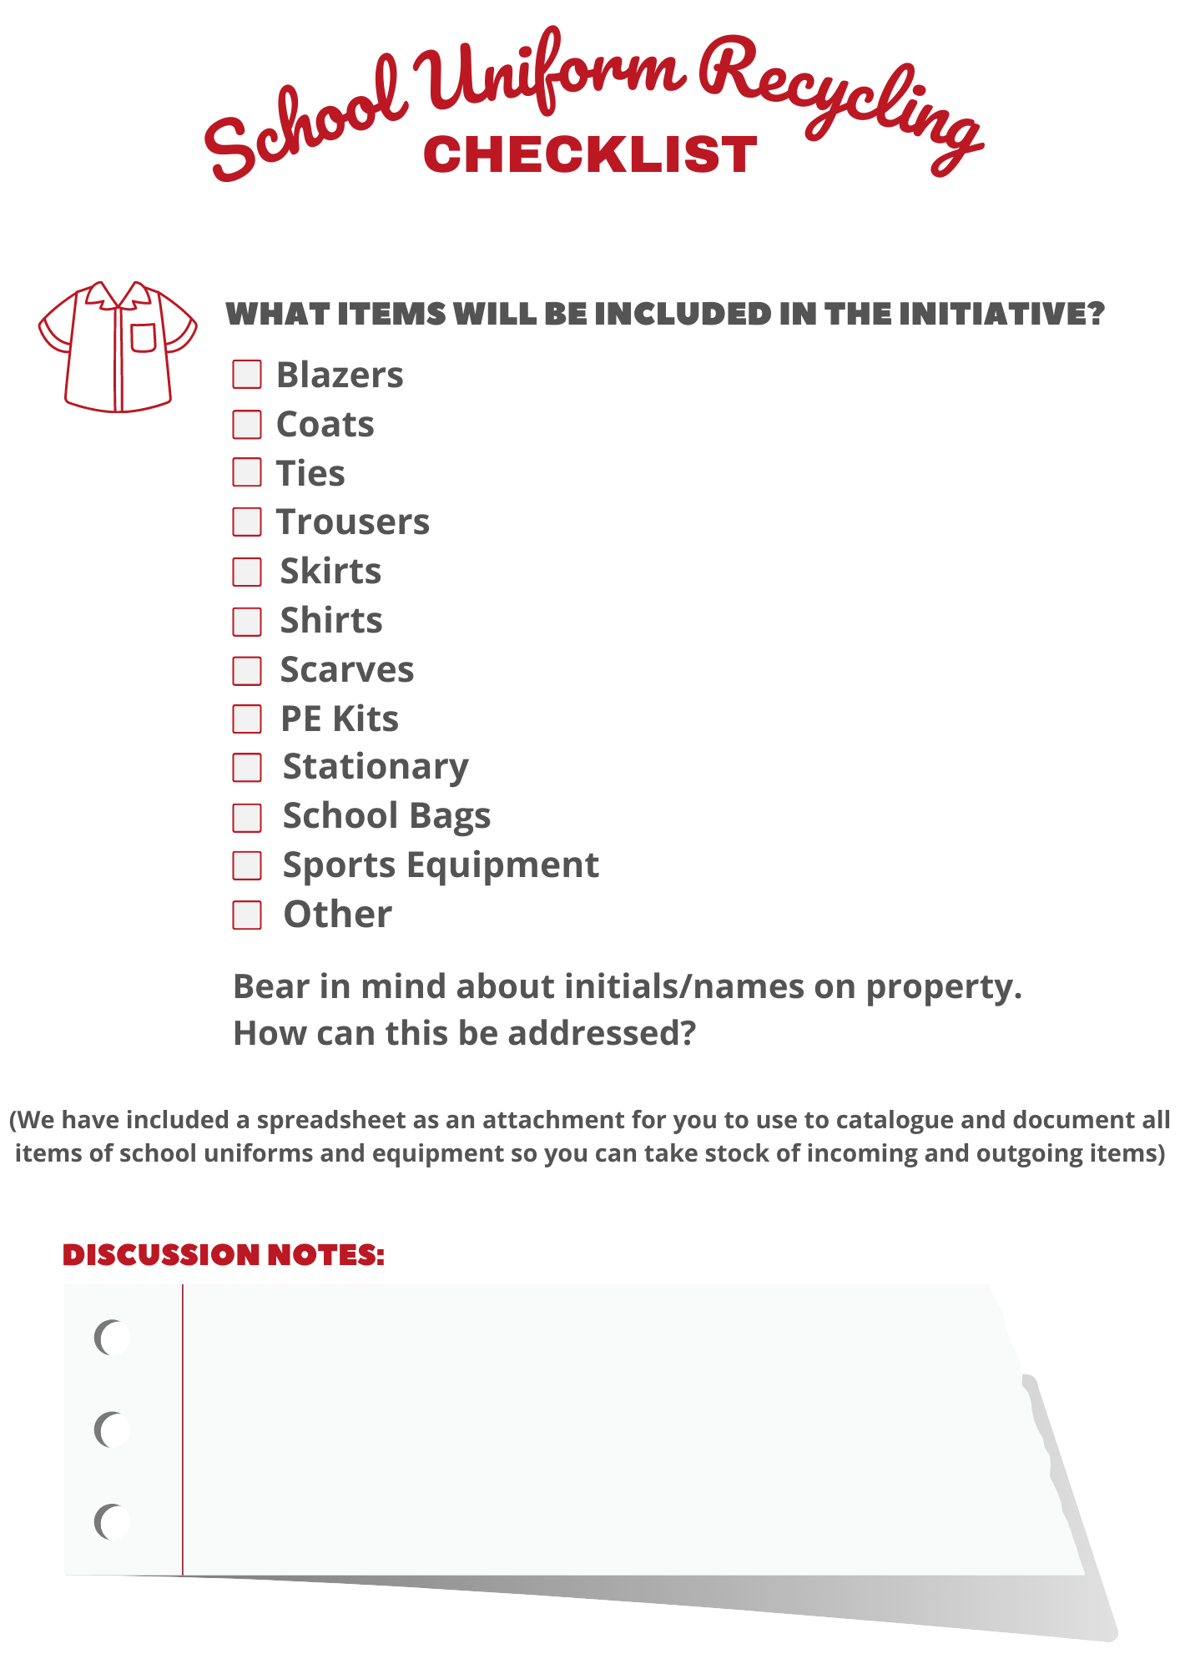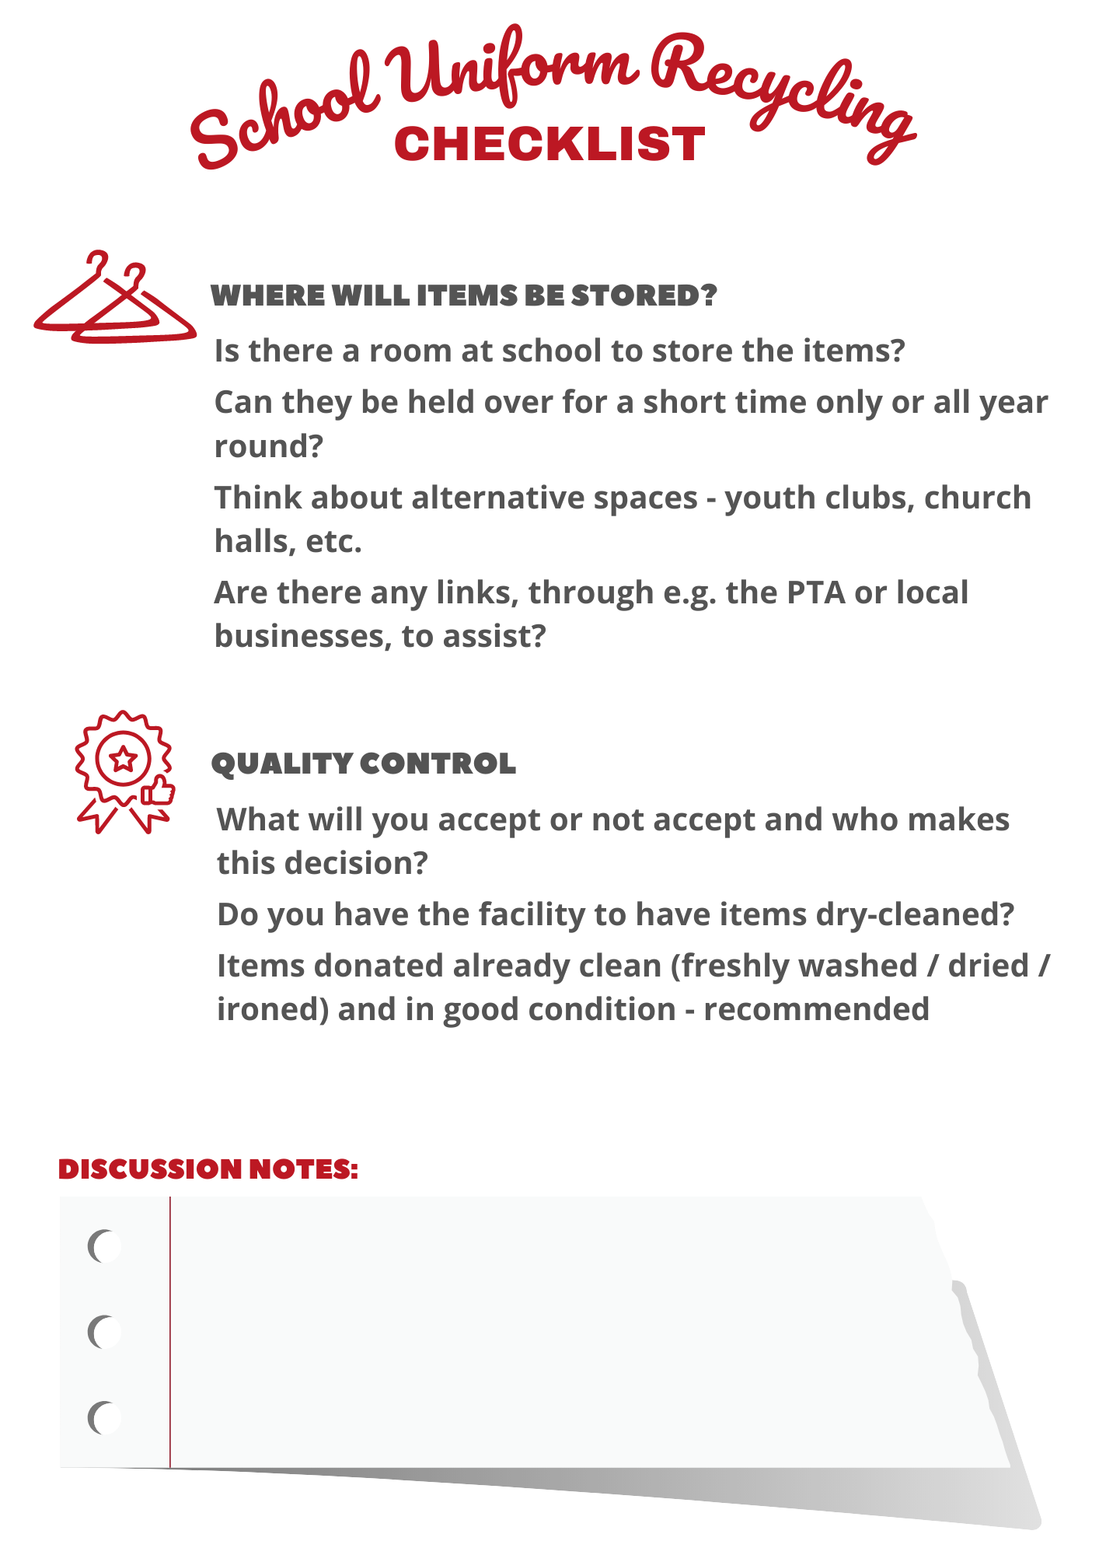

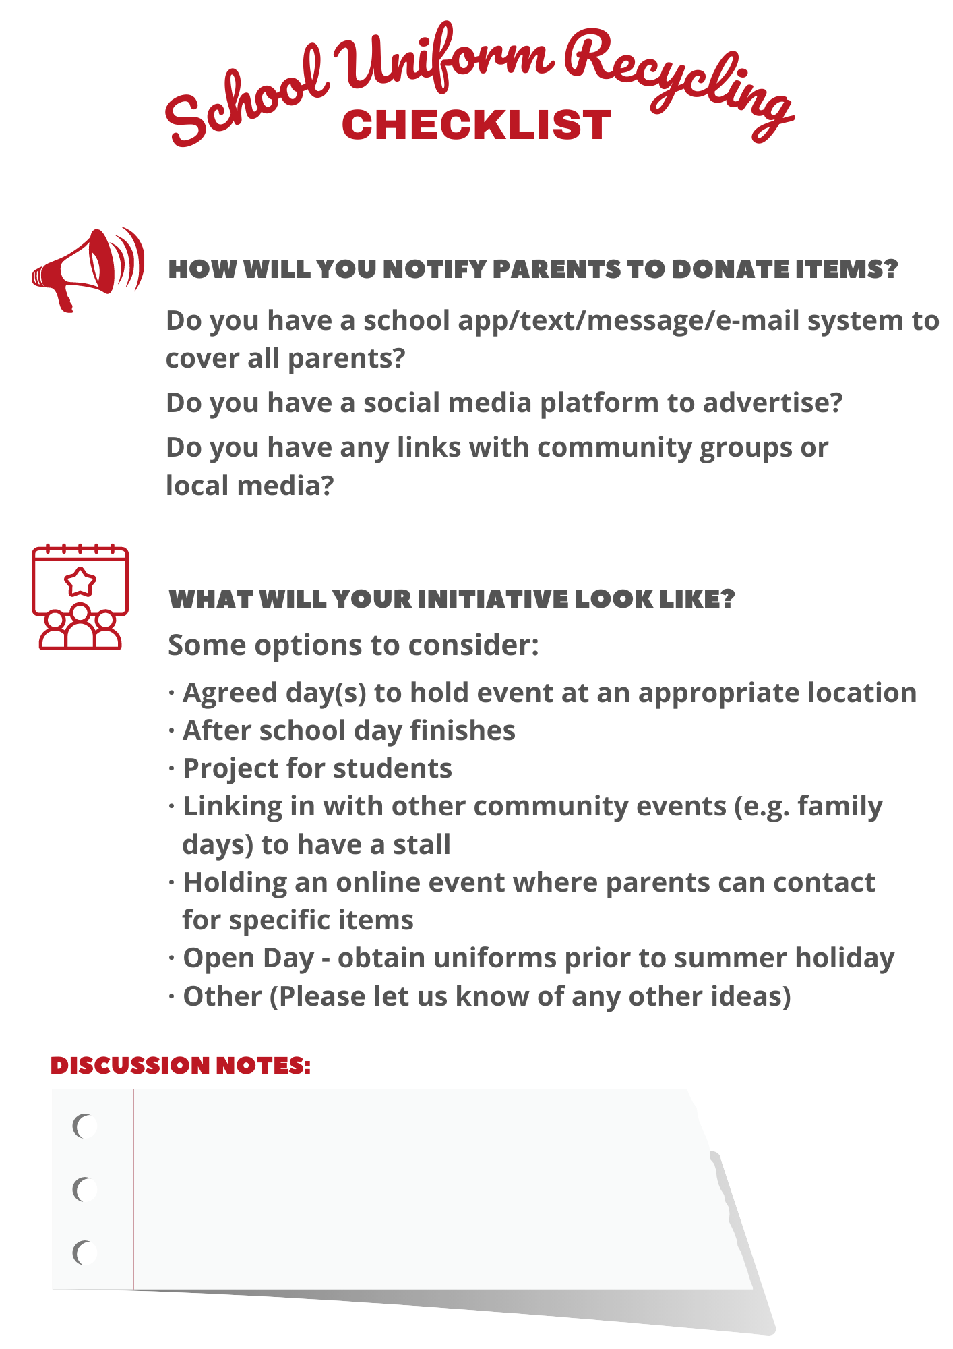
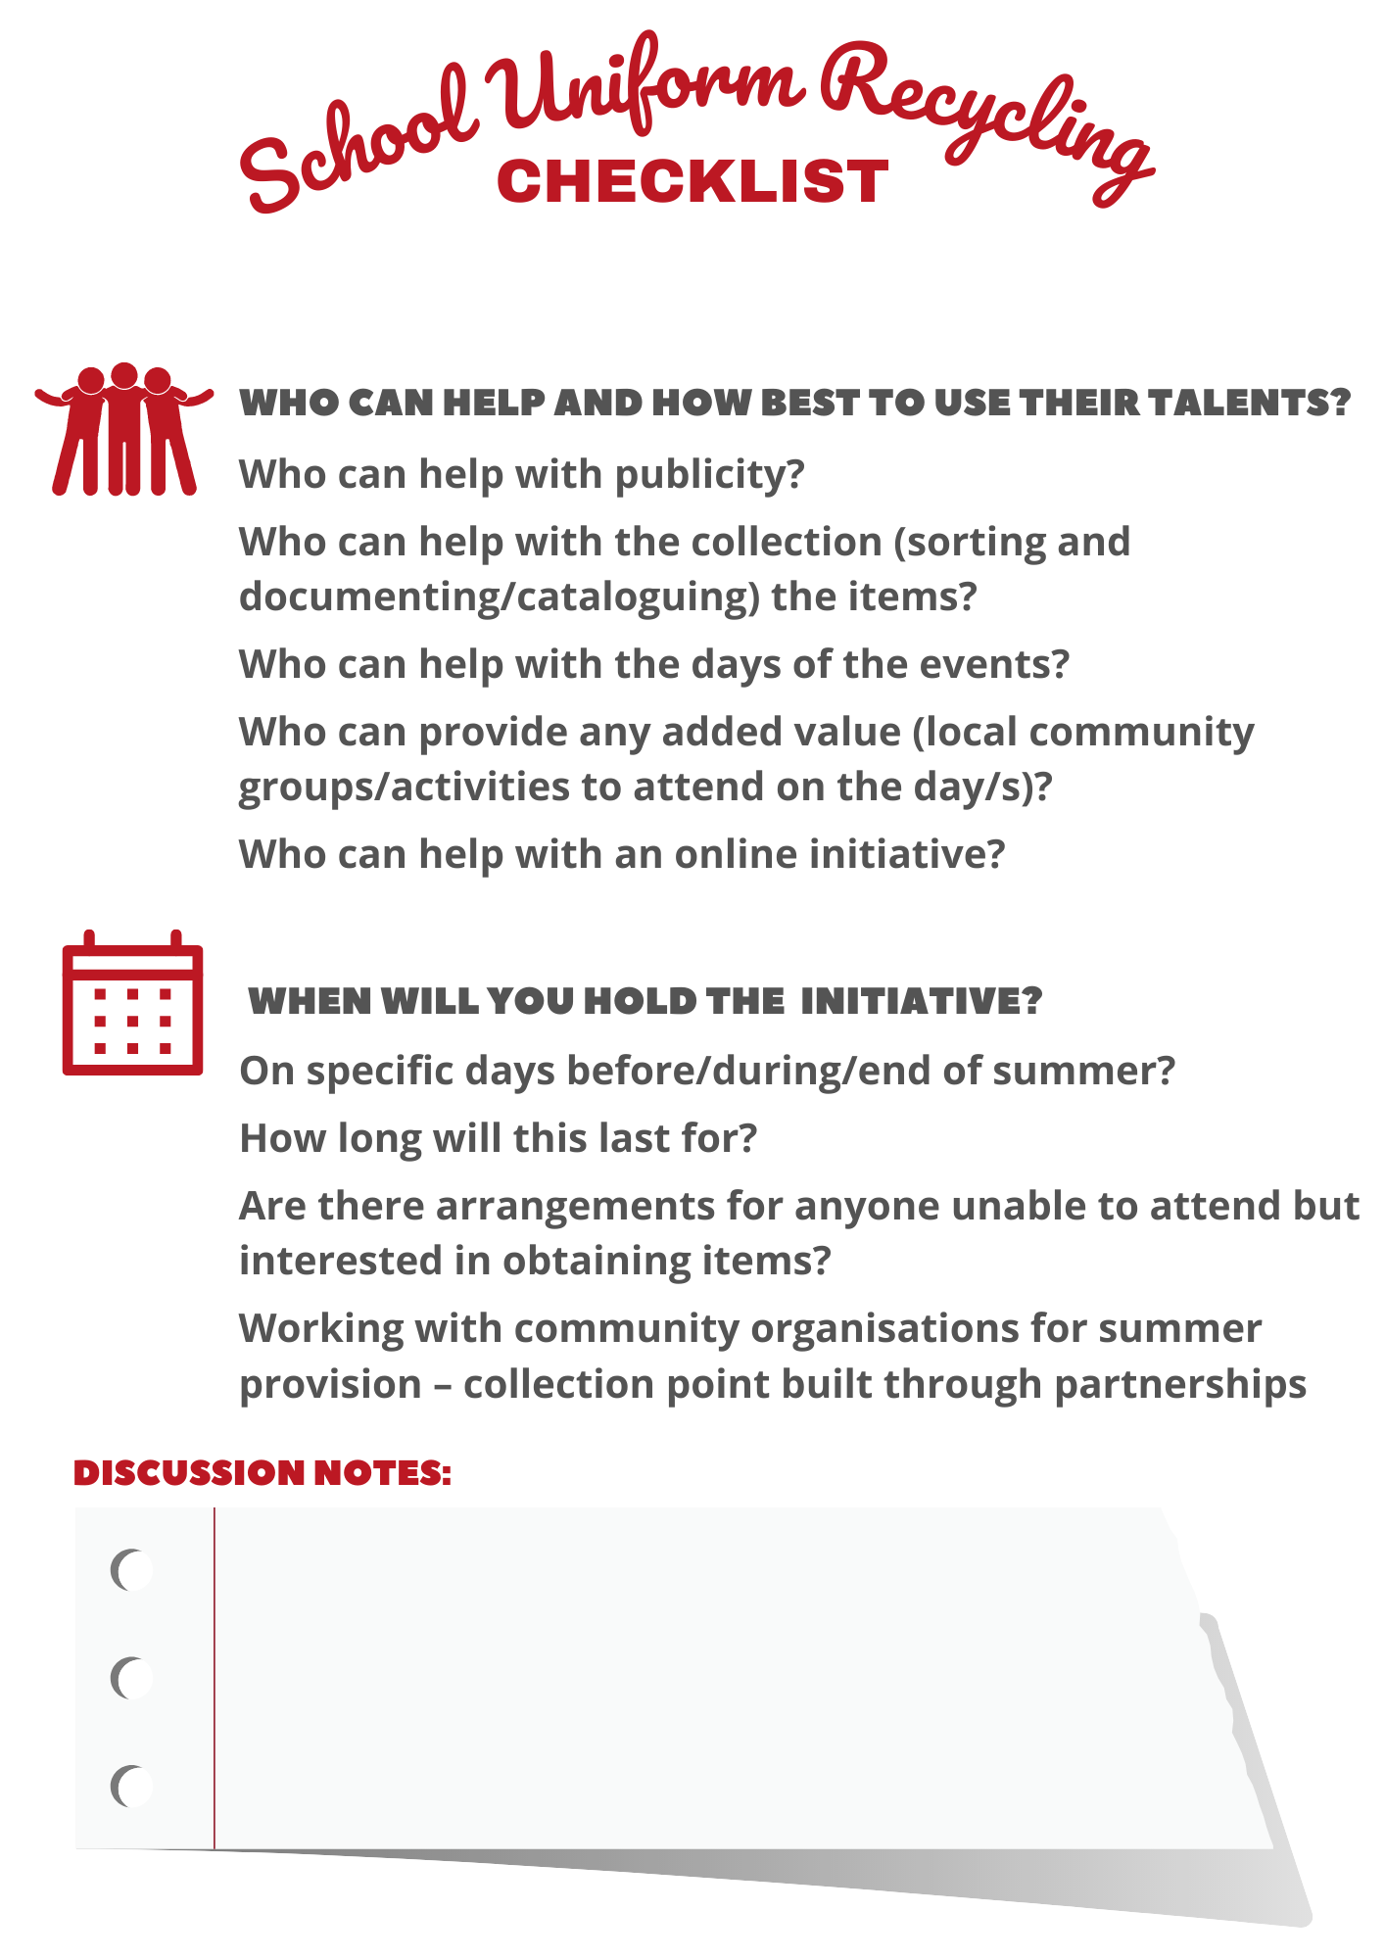
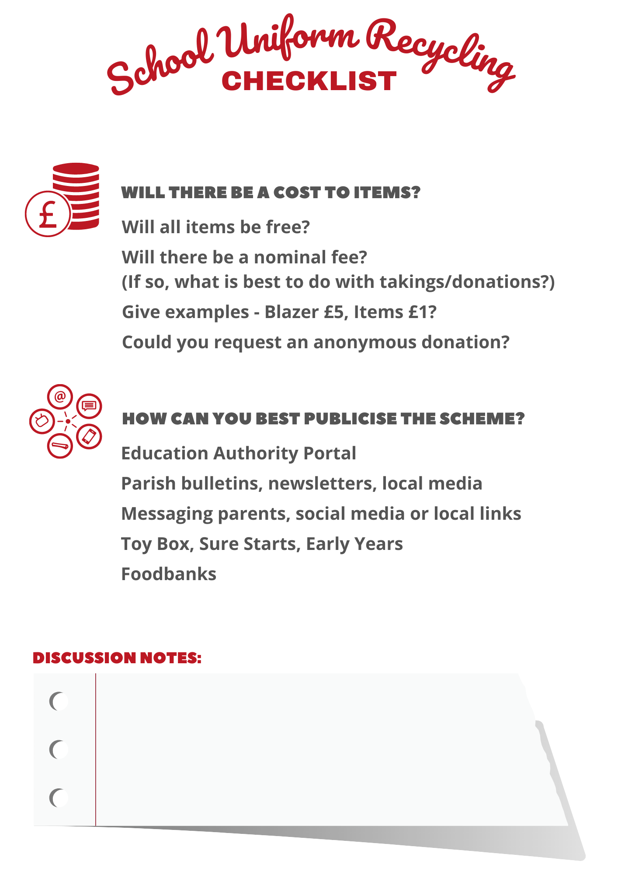

EVALUATION

We are keen to ensure any School Uniform Recycling Initiative is evaluated to measure its impact. This should include quantifiable measures such as the number of uniforms donated, distributed and the number of families benefitting. Costings can be calculated by attributing values to each item in order to demonstrate the savings made as compared to full price uniforms.

We have provided evaluation templates for both parents and schools to complete in order to gain as much information as possible. To accompany the quantitative data we will also ask for qualitative information to understand how the initiative has impacted on families.

Please complete the templates as instructed and send through to us at localityplanning@ci-ni.org.uk so we can add these to an evaluation report.

FUTURE STEPS

There will likely be a surplus of items that have not been recycled so discussion and agreement should be made to identify where these will go. Ideas might include:

- Keeping at a storage space in school so parents can contact at any time to enquire
- Keep at school for the following year’s scheme
- Donate to local charity shops for selling on
- Many schools also sign up to the Cash for Clobber initiative each year (http://www.cookstowntextilerecyclers.com/cash-for-clobber) which is facilitated by Cookstown Textile Recyclers in conjunction with Eco Schools - This teaches school children, community groups etc the environmental and social benefits of recycling textiles whilst also raising some valuable funds for themselves
(A uniform exchange could perhaps be linked to this scheme with participants encouraged to do a clear out of their unwanted clothing whilst keeping items of school uniform separate for any exchange scheme in place)
- Please contact us if you have any other ideas

CONTACT US

If there is anything that you think has been missed from this School Uniform Recycling Toolkit, or if you have any related thoughts, please get in touch.

Contact Darren Curtis at localityplanning@ci-ni.org.uk

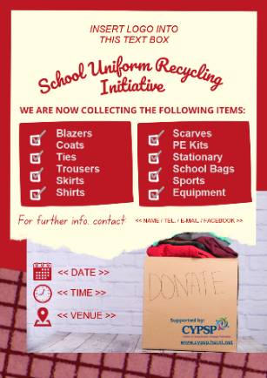
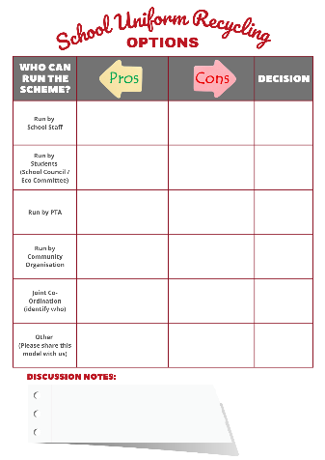
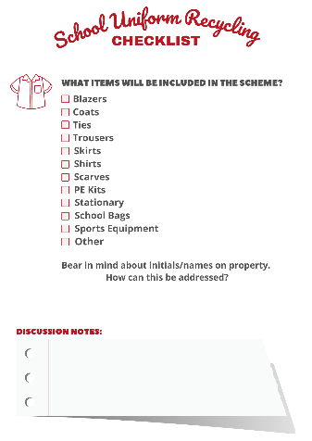

[TEMPLATE 1] [TEMPLATE 2] [TEMPLATE 3]

Who Will Run the Initiative? Points for Discussion Checklist Donation / Collection Flyer

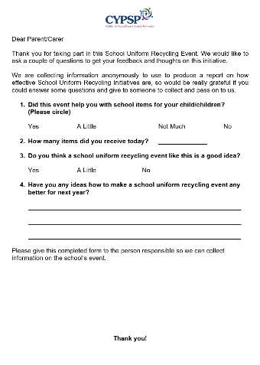
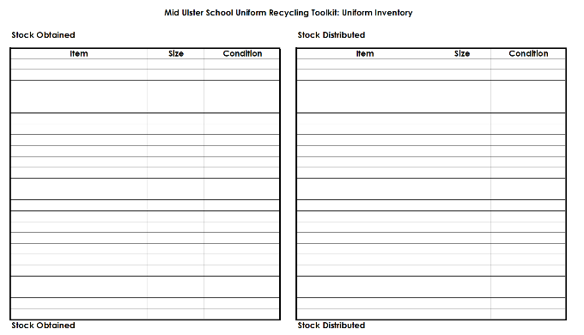
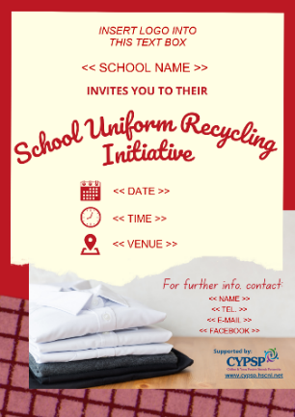

[TEMPLATE 4] [TEMPLATE 5] [TEMPLATE 6]

Event Flyer Inventory Spreadsheet Parent/Carer Evaluation

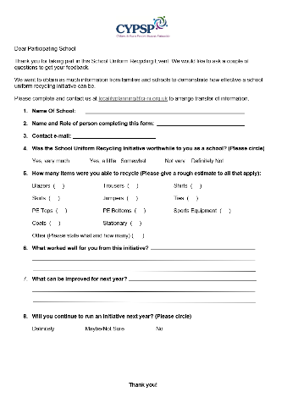

[TEMPLATE 7]

School Evaluation
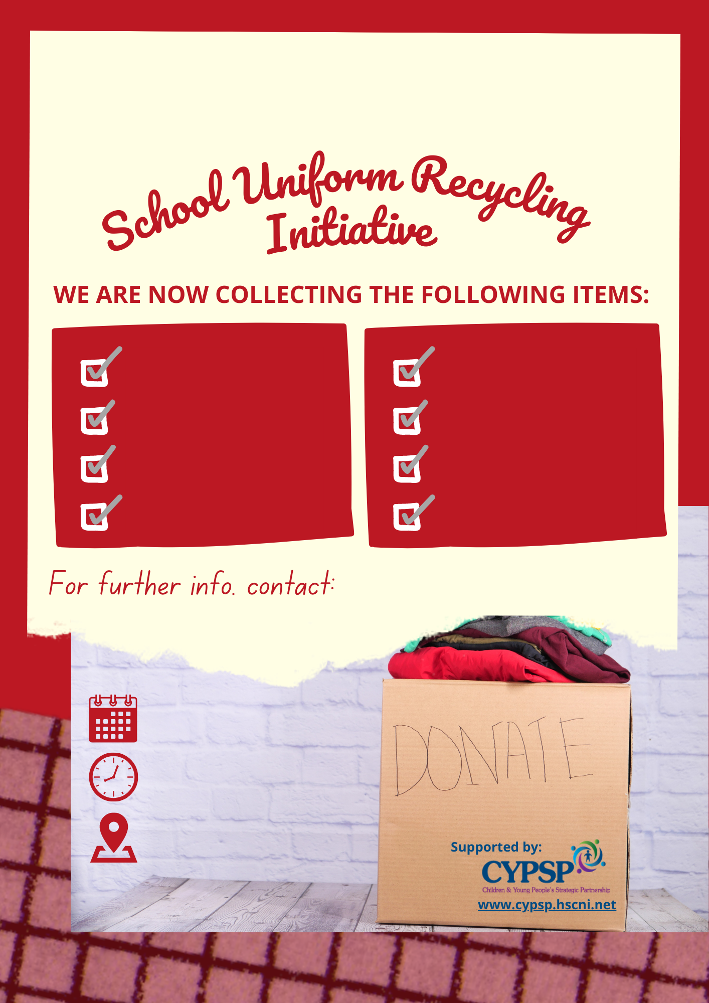

INSERT LOGO OR SCHOOL NAME INTO THIS TEXT BOX
Scarves
PE Kits
Stationary
School Bags
Sports Equipment
<< NAME / TEL. / E-MAIL / FACEBOOK >>
<< DATE >>
<< TIME >>
<< VENUE >>
Blazers
Coats
Ties
Trousers
Skirts
Shirts

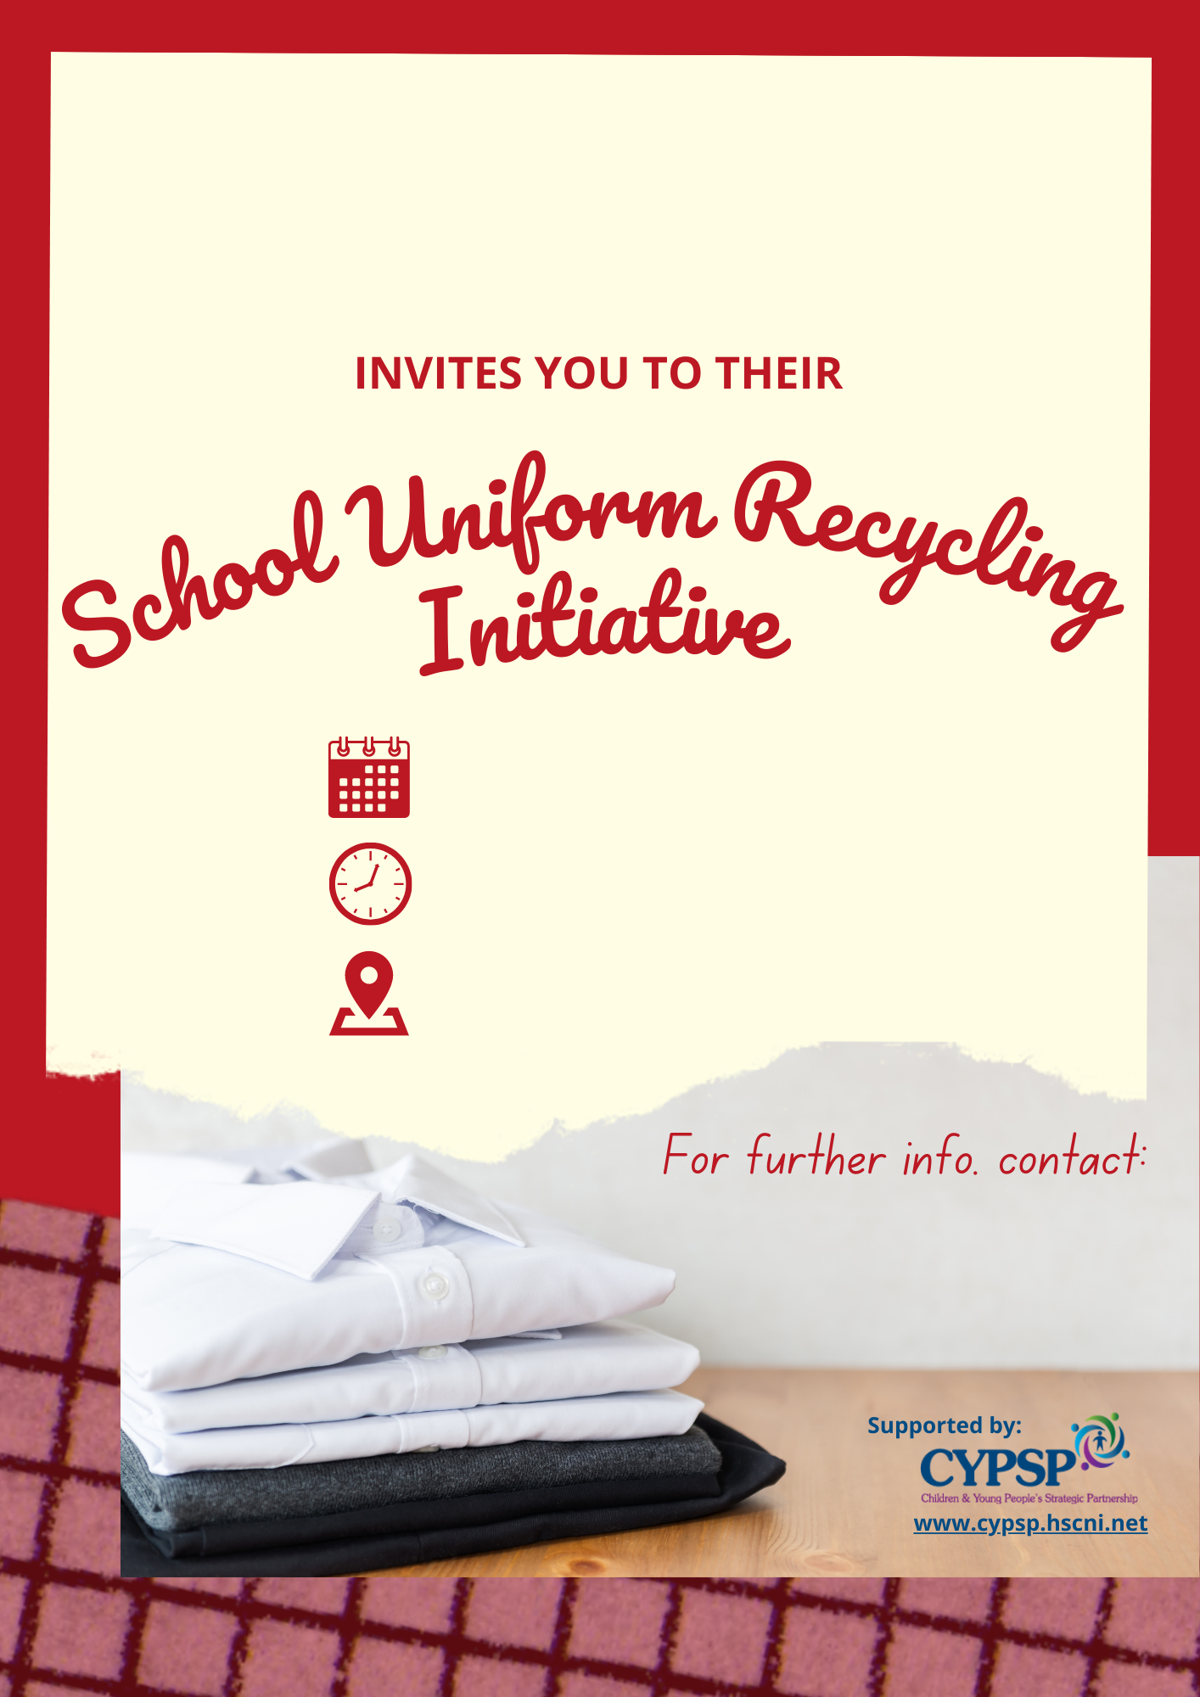
<< NAME >>

<< TEL. >>

<< E-MAIL >>

<< FACEBOOK >>

INSERT LOGO INTO
THIS TEXT BOX
<< SCHOOL NAME >>
<< TIME >>
<< DATE >>
<< VENUE >>
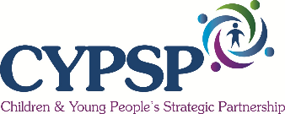

Dear Parent/Carer

Thank you for taking part in this School Uniform Recycling Event. We would like to ask a couple of questions to get your feedback and thoughts on this initiative.

We are collecting information anonymously to use to produce a report on how effective School Uniform Recycling Initiatives are, so would be grateful if you could answer some questions and give to someone to collect and pass on to us.

- Did this event help you with school items for your child/children? (Please circle)

Yes A Little Not Much No

- How many items did you receive today? ( )

- Has this School Uniform recycling event helped you save money or reduce costs for your family? (Please circle)

Yes, a lot Yes, a bit Not Really Definitely Not

- Do you think a school uniform recycling event like this is a good idea?

Yes A Little No

- Have you any ideas how to make a school uniform recycling event any better for next year?

Please give this completed form to the person responsible so we can collect information on the school’s event.

Thank you!

Dear Participating School

Thank you for taking part in this School Uniform Recycling Event. We would like to ask a couple of questions to get your feedback.

We want to obtain as much information from families and schools to demonstrate how effective a school uniform recycling initiative can be.

Please complete and contact us at localityplanning@ci-ni.org.uk to arrange transfer of information.

- Name Of School:

- Name and Role of person completing this form:

- Contact e-mail:

- Was the School Uniform Recycling Initiative worthwhile to you as a school? (Please circle)

Yes, very much Yes, a little Somewhat Not Very Definitely Not

- Was the Toolkit useful to your school in helping to run an Initiative?

Yes, very much Yes, a little Somewhat Not Very Definitely Not

- How many items were you able to recycle (Please give a rough estimate to all that apply):

Blazers ( ) Trousers ( ) Shirts ( )

Skirts ( ) Jumpers ( ) Ties ( )

PE Tops ( ) PE Bottoms ( ) Sports Equipment ( )

Coats ( ) Stationary ( )

Other (Please state what and how many) ( )

- What worked well for you from this initiative?

- What can be improved for next year?

- Will you continue to run an initiative next year? (Please circle)

Definitely Maybe/Not Sure No

- Any further comments about your Initiative or Toolkit?

Thank you!

There is a lot of further reading and information that can be accessed online. We have highlighted our sources on Page 4 (the section on ‘Evidence’) in grey and underlined so you can click on these to open for more information and evidence behind these figures. Throughout the document, all underlined text in grey takes you to the corresponding website or e-mail address.

We have also included a suite of further reading and information in relevant areas that can be accessed online and these can be visited by either scanning the QR code with your mobile phone or clicking on the area highlighted underneath the image of a mobile phone.

This is not the exhaustive list of all relevant information however gives a taste of what exists online for those who wish to learn more about this area of work

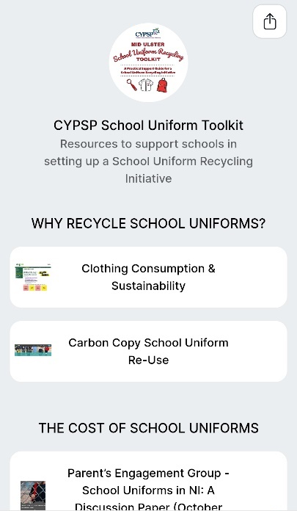

Alternatively, visit the School Uniform Recycling Initiative Resource Hub
by clicking HERE

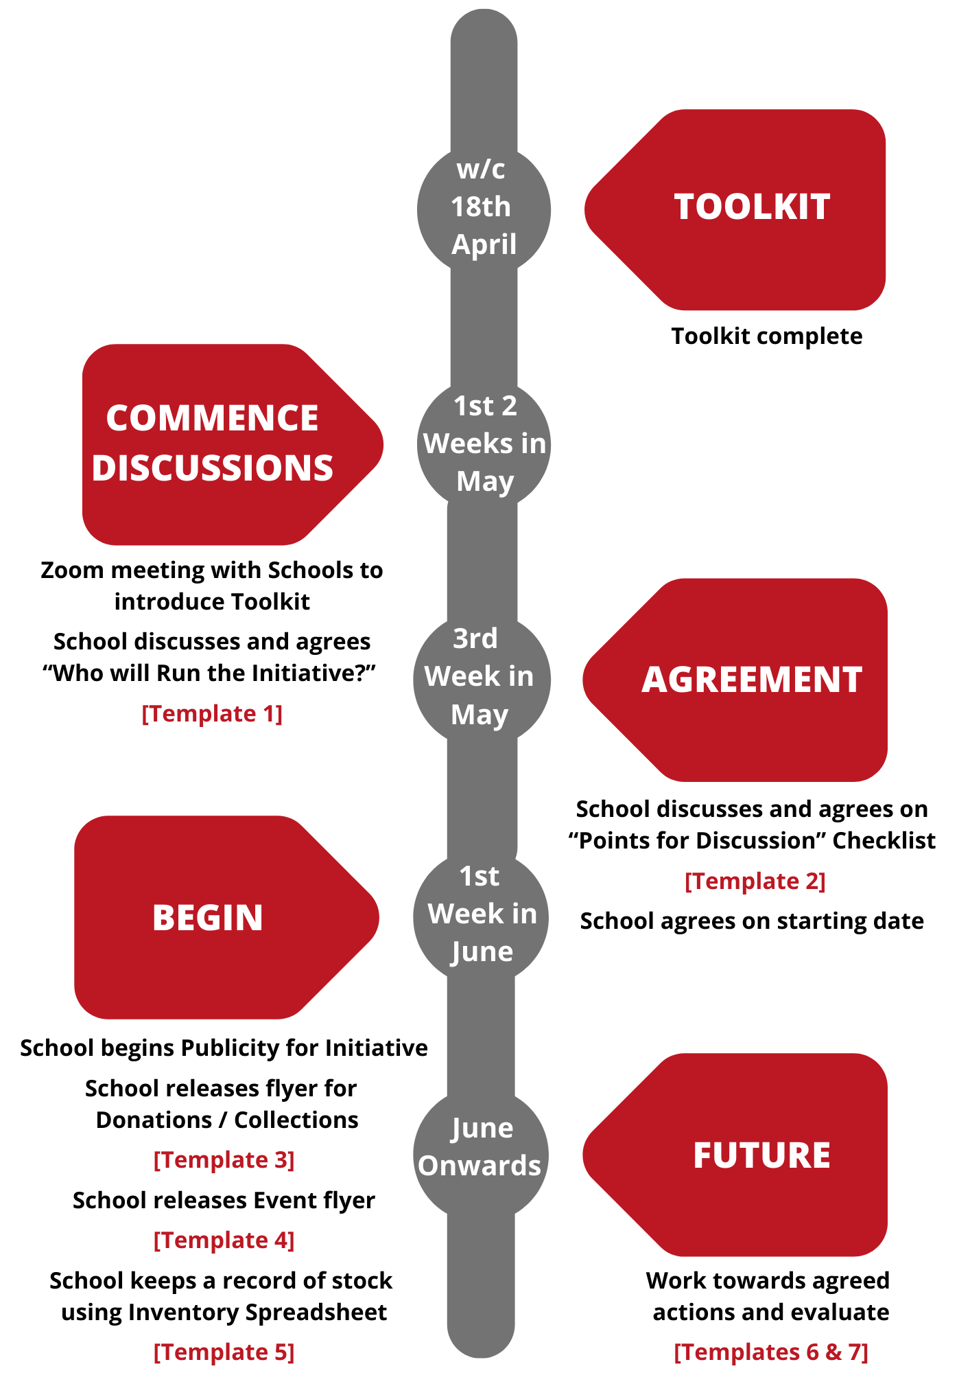

Engaging with pupils to become involved from the outset creates a collective approach with ownership spread across the school. The Student/School Council or Eco-Committee would be a natural starting point in this respect.

In Mid Ulster 100% of schools are registered on the Eco School programme with many having received at least one Green Flag award to date. By your schools Eco-Committee being involved in a School Uniform Recycling Initiative it creates a fantastic opportunity to get on board with recycling and waste reduction within your school. This can be documented as a great example of work around these topics when working towards or renewing your schools Green Flag award.

Mid Ulster District Council is fully committed to the Eco-Schools process and to supporting local schools in becoming Green Flag accredited schools within the Eco-Schools programme. To this end the Council Officers will offer assistance to local schools as they design and implement their Eco-schools action plans.

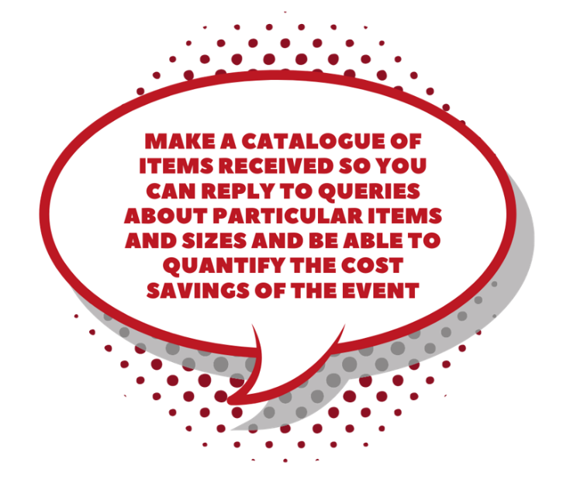

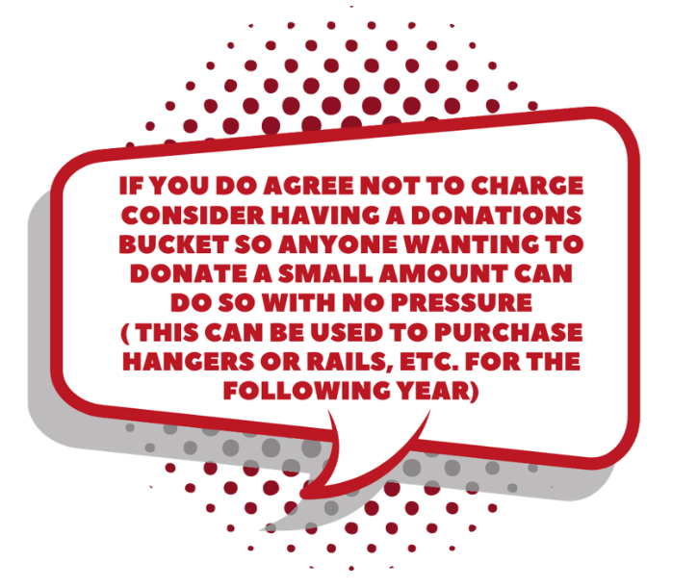

For more information contact one of the Mid Ulster Council Recycling Education Officers on 03000 132 132.

For students (e.g. Lower Sixth) there are opportunities to link involvement with a School Uniform Recycling Initiative to volunteering hours and awards recognised both locally and nationally. The two main volunteering bodies in the local area are Volunteer Now and the Mid Ulster Volunteer Centre.

Volunteer Now

This is the lead organisation for promoting and supporting volunteering across Northern Ireland, providing access to opportunities and encouraging people to volunteer. They are a resource for volunteer-involving organisations providing support on involving volunteers, governance and safeguarding.

Volunteer Now Impact Awards: “Young volunteers inspiring change”: Launched in June 2021, this programme has replaced the Millennium Volunteers programme and enables all young people across Northern Ireland to receive recognition for the hours that they complete through its online platform (powered by Be Collective).

Registration is on the Volunteer Now website (www.volunteernow.co.uk) which requires applicants to create a profile and join your volunteering organisation as well as the Volunteer Now Impact Awards group. A certificate is sent electronically upon completions of 50,100 and 200 hours of volunteering. This will appear in a social profile and will form part of a Social CV, ready for download, printing and saving. All volunteering history will be automatically inserted.

Mid Ulster Volunteer Centre

Based in Magherafelt and Cookstown, the Mid Ulster Volunteer Centre seeks to encourage social inclusion by working with the community to help further personal development through volunteering and/or training.

EPIC Awards: EPIC stands for Empowering People In Communities and is a free initiative to recognise and validate the contributions of volunteers in the community who make a commitment of at least 50 hours within any 12-month period.

There are three levels of EPIC Award:
Bronze Award - 50 hours
Silver Award - 100 hours
Gold Award - 200 hours

This can be gained through volunteering with one organisation or with multiple organisations simultaneously. On completion of relevant hours, volunteers receive a certificate (digital copy can be requested) of personal recognition for their contribution which can also be used as part of a CV, personal statement or job application. If volunteering hours are less than 50 hours a recognition certificate can be issued.

More information can be obtained at: www.midulstervolunteercentre.org

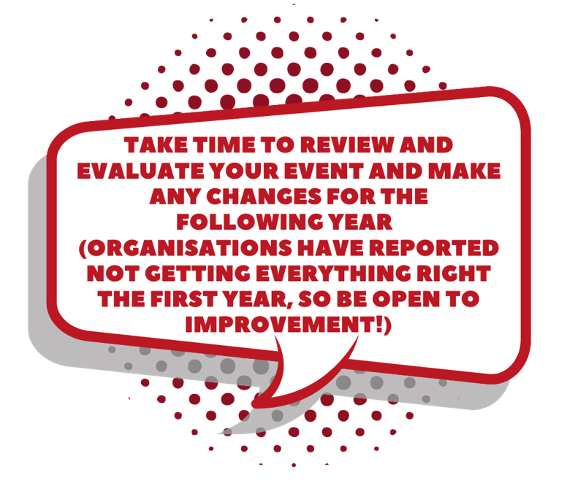

This Toolkit was designed and written by representatives of the Dungannon and Mid Ulster Locality Planning Groups.

Members of the Planning Group were Emma McGeehan (MUDC), Loraine Griffin (COSTA), Joanne Dougan (STEP), Nichola Simpson (Causeway & Mid Ulster Women’s Aid) and Mary Tennyson (GOLD Sure Start, Cookstown).

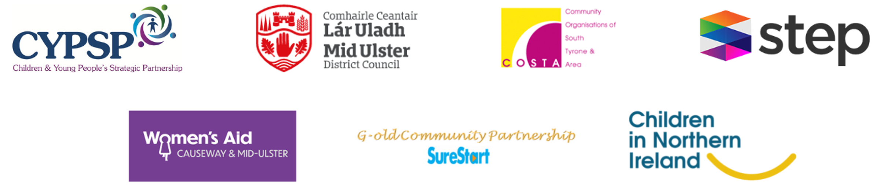

For further information, contact Darren Curtis, Locality Development Officer in the Southern Area, or Emma McElhone, Locality Development Officer in the Mid Ulster Area:

darren@ci-ni.org.uk

Emma.McElhone@northerntrust.hscni.net

May 2022

